**Step -3 Docker default parameters**

* **1. Verify Docker Package Installation**
* If **docker-ce and docker-cli** are installed in the VM, then the packages related to docker will be available in dpkg (Package manager in Ubuntu
* **the command - dpkg -l | grep docker-ce**

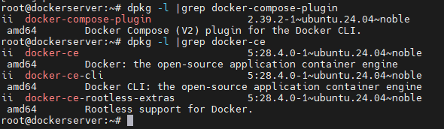

* **Explanation:**
* **Dpkg –l list all installed packages**
* **Grep docker –ce filters the output to show only docker releated packages**



* **2 . To verify the Docker compose plugins installation** in dpkg run
* **command - dpkg -l | grep docker-compose-plugin**

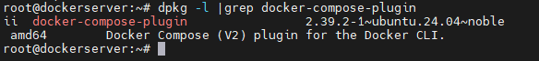

* **3. To verify the version of docker installed** run
* **the command –docker –version**



* **4. To get more information on docker**
* run the command – **docker info**.

**Key Information Displayed:**

* Docker client & server info
* Container status & images
* Cgroup driver & version
* Plugins (volumes, network)
* Docker Swarm status
* Default runtime
* Docker host OS kernel
* Docker root directory

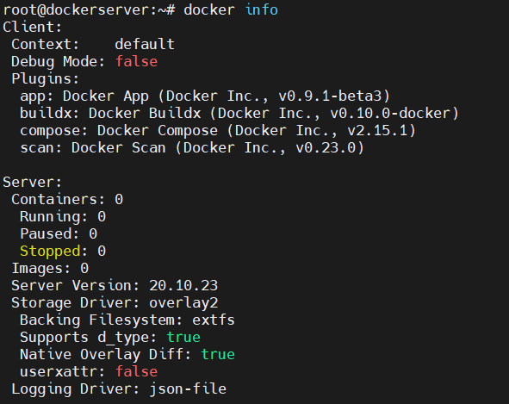

* **5. Docker root directory is /var/lib/docker.** To know the root directory fo docker run the command – **docker info**



To see the list of files available in the docker root directory run

**the command - ls –l /var/lib/docker/**

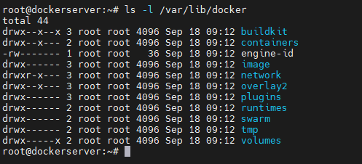

* **6. The default registry to download docker images is**

**https: //index.docker.io/v1/.** Docker images from this path are downloaded by docker-cli to the local system to create containers.



**7. Normal User Permissions**

* By default, normal users (non-root) have permission restrictions.
* Example: Running docker info as a normal user will only display **client information**, not server details.

**8. Allow Normal User to Run Docker Commands.**

To allow a normal user (e.g., testuser) to run Docker commands:

**Step 1: Check Docker Group**  
Docker creates a group docker during installation.

**Commands:**

**Cat /etc/group l grep docker**

**Cat /etc/passwd l grep docker**



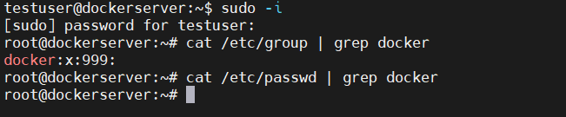

**2.** To add a user named testuser to the docker group run the command –

**usermod -aG docker testuser.** Also run the command

**cat /etc/group | grep docker** to check if the user is added to the group or not.



1. As a new user has been added to the docker group, the docker service has to be restarted to apply the changed that have been added.

Run the command – **systemctl restart docker** to restart the docker service. Then check the status of docker service by running the command – **systemctl status docker**. The docker service should be active (running) status.

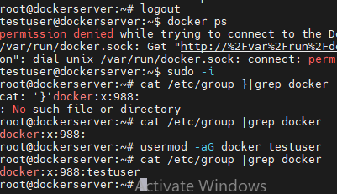

Note: The /var/run/docker.sock socket file is contacted by the Docker-cli to connect to docker server.

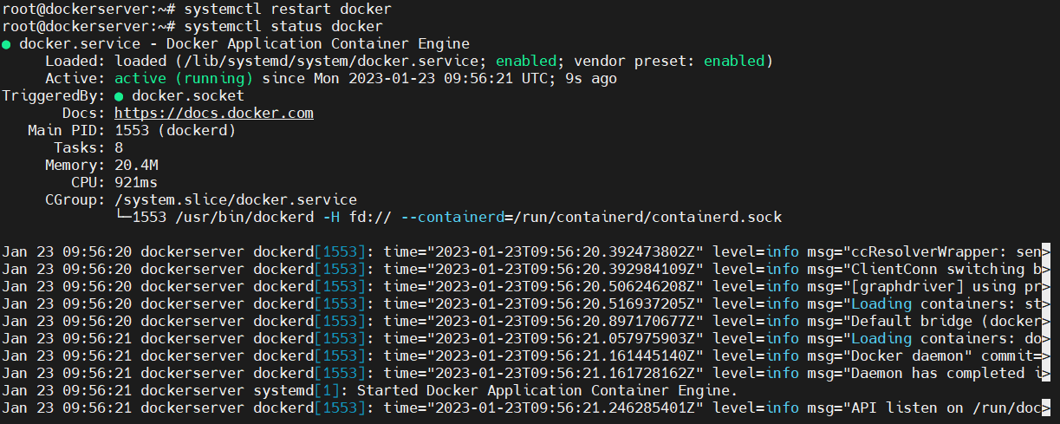

1. Now switch to normal user (testuser) and run the command **docker info** to check if normal user is able to run docker commands. If the normal user is still not able to run the docker command reboot the VM by running the command reboot.

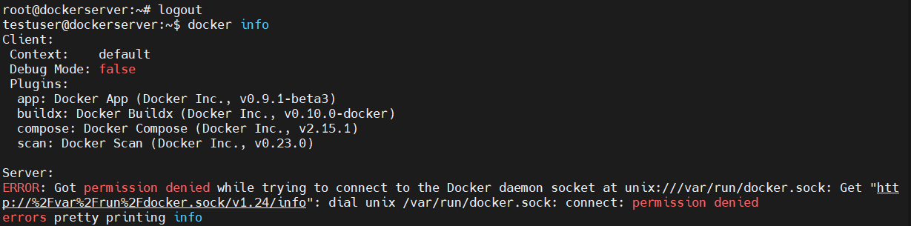



1. Relogin to the VM and run the docker info command with normal user (testuser). For sure you will be able to run.

